Day 36 Revisit

Spring – It’s a Open Source Java Based framework to create Enterprise Level Java Application.

Spring use Ioc & DI Design Pattern

Spring contains many modules like core, webmvc, data, security, test etc.,

Spring also contains AOP module (Aspect Oriented Programming)

Spring is the base framework of Spring Boot.

applicationContext.xml Factory Design Pattern, Many Annotations (@Bean, @Autowired, @Component, @Service, @Controller, @Transaction)

IoC – Inversion of Control – Driving own car or renting a car to go office every day.

(Spring will act as a IoC container, which will take care managing the bean life cycle)

Object creation and destroy will happen with the help of spring.

DI – (Dependency Injection) – Required dependencies to create an object will be injected by DI.

Types Of Dependency Injection

1. Constructor Injection
2. Setter Injection

Two ways of defining the dependencies

1. Using xml file --- configuration driven
2. Using annotation -- Annotation Driven

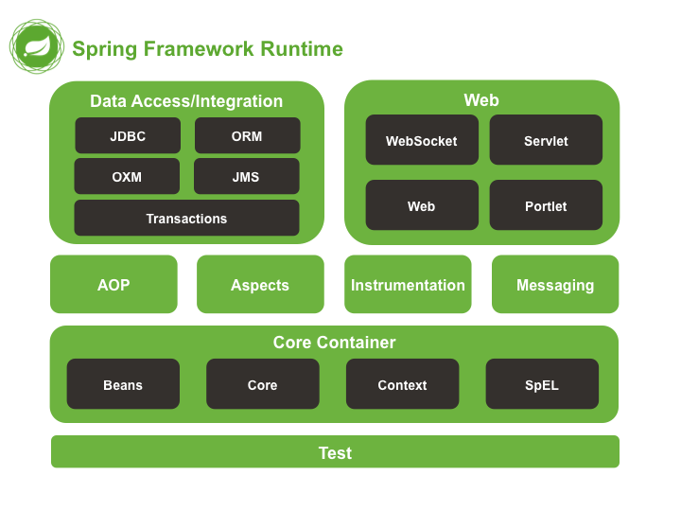

If you like to create a web application using Spring – Spring Web or Spring MVC

MVC – Is a Design Pattern

Model (Data – Entity Bean Class [represents a table in the database])

View ( UI – Template/HTML)

Controller ( Controls the entire operation and flow of data)

@Controller [Map any URI with Java methods] – It’s a Special Kind of Java Class which connects the URI and the (Java) Application code.

@PathVariable

@PathParam

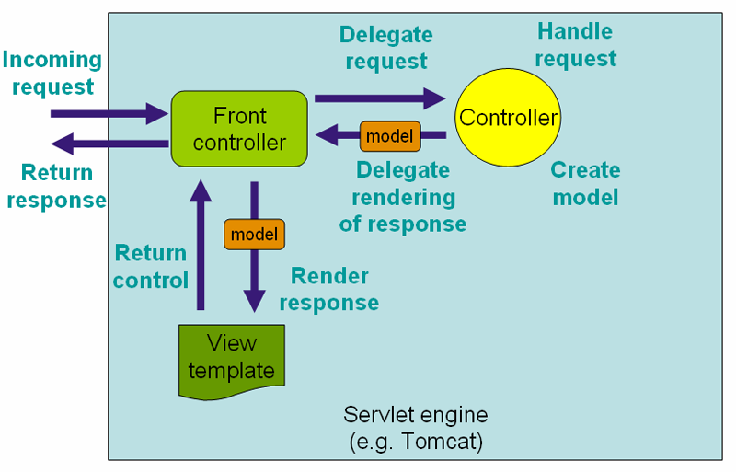

Front controller (Dispatcher Servlet) is the Entry point of Spring Web Application.

All the Web applications follows Request & Response model [Client & Server Concept]

|  |  |  |
| --- | --- | --- |
|  | Client Side Coding (Technologies) | Server Side Coding (Technologies |
|  | HTML, CSS, JS, AJAX | Servlet, JSP, JSF, Web Services [php, asp, …] |
|  | Web Browser is used to send Request | Web/Application Server is used to process the request and generates the output. |
|  | HTML Engine, JS Engine, Style Engine | Validate the Request, Execute the Server side code to generate Response Ojet |
|  |  |  |

1. FrontController (Dispatcher Servlet)
2. ModelAndView (Both Data & Template -html )

Spring MVC Demo Application

* Open Eclipse
* Create a new Dynamic Web Project (File 🡪 New 🡪 Dynamic Web Project)

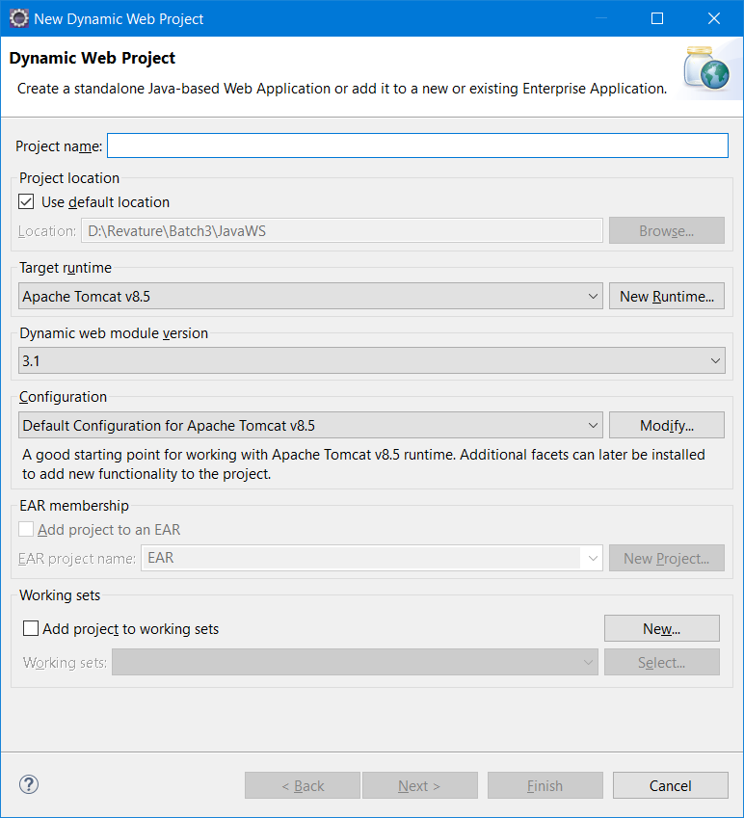

Web.xml is also called as Deployment Descriptor -- It’s the entry point of normal web application

<wecome files>, Servlet Mapping

Web applications can also be created without web.xml. Instead f web.xml annotations can be used.

Web.xml file will also be present in Web Server’s config folder.